THE DYNAMICS

**ISSUE # 5 MONTHLY**

**NEWSLETTER**

**GLOBAL CENTER FOR SOCIAL**

**DYNAMIC RESEARCH**

12 December 2024

# Here’s what has happened in the last month and what’s to come!

In this newsletter

Dear Readers,



As the year draws to a close, we are delighted to bring you the December issue of The Dynamics, the official newsletter of the Global Center for Social Dynamics Research. This edition celebrates the culmination of a year marked by groundbreaking research, impactful collaborations, and insightful discussions on the ever-evolving interplay of society, technology, and policy.

In this issue, we explore the transformative trends shaping our global landscape, focusing on topics like artificial intelligence, robotics, social equity, and sustainable development. From analyzing the social implications of emerging technologies to spotlighting innovative solutions to pressing societal challenges, our articles aim to inform, inspire, and engage our diverse readership.

We also take a moment to reflect on our achievements over the past year, including the launch of new initiatives, partnerships, and publications that align with our vision of fostering research-driven societal growth. Highlights include the ongoing research on the "Social Fabric of AI" and the expansion of our educational outreach programs aimed at equipping future leaders with the tools to navigate a rapidly changing world.

As always, we welcome your feedback, ideas, and contributions to make *The Dynamics* a vibrant platform for knowledge exchange. Thank you for being a part of our journey in 2024. Let’s continue to advance together towards a more equitable, informed, and dynamic society.

Report on the Upcoming Conference

Launch and Publication of Journal Vol. 1(1)

Community Updates

Story of Impact

Research Publication

Highlights

**LETTER FROM EDITOR**

**Dear Readers,**

**Since** last many Months, we have witnessed profound shifts in global dynamics—be it the rapid advancements in technology, evolving sociopolitical landscapes, or the ongoing quest for equity and sustainability. These shifts reaffirm the importance of interdisciplinary research and collaboration in addressing the complexities of our interconnected world.

In this issue, we delve into some of the most pressing topics of our time. Highlights include:

An insightful feature on the role of social dynamics in shaping policies for climate resilience.

Research spotlights that explore the intersection of artificial intelligence and societal structures.

Perspectives from global scholars on fostering inclusive communities in an era of rapid urbanization.

Updates on the Center’s initiatives, partnerships, and upcoming events.

As always, we remain committed to amplifying diverse voices and fostering conversations that inspire action. I extend my heartfelt gratitude to our contributors, researchers, and readers who have been instrumental in making Dynamics a platform for meaningful dialogue.

Let us move forward into the new year with renewed determination and a shared vision for a more equitable and sustainable world.

**Warm regards,**

**Dr. Neelam C Dey**

**Chief Editor, The Dynamics**

**Executive Director and Director Research Global Center for Social Dynamic Research** [**drneelamcdey@globalcsdr.com**](mailto:drneelamcdey@globalcsdr.com)

REPORT ON THE UPCOMING CONFERENCE



The Global Center for Social Dynamic Research is pleased to announce the organization of an International Conference on Mental Health of Adolescents and Youth, scheduled to be held in February 2025. The tentative date for this much- anticipated event is 20th February 2025.

The mental health of adolescents and youth is a critical issue that demands immediate attention, especially in the face of contemporary challenges such as technological overexposure, academic pressures, social inequalities, and the lingering impacts of the global pandemic.

This conference aims to bring together leading experts, practitioners, educators, policymakers, and researchers from across the globe to share insights, discuss challenges, and propose innovative solutions for fostering mental well-being among young people.

**THE MULTIDISCIPLINARY E-JOURNAL: GLOBAL E- JOURNAL OF SOCIAL SCIENTIFIC RESEARCH VOL. 1(1)**



# Community News

As we approach the end of 2025, the Global Center for Social Dynamic Research is proud to share updates on the incredible work being done by our community to drive positive social change.

**Launch of the Mental Health Awareness Campaign** In preparation for the upcoming **International Conference on Mental Health of Adolescents and Youth** in February 2025, our community has launched a

month-long awareness campaign. The campaign aims to destigmatize mental health issues among young people and encourage open dialogue. Activities include online workshops, social media initiatives, and community outreach programs in schools and colleges.

**Collaborative Research Projects on Climate and Society**

This month, researchers from the Center have initiated collaborative projects focusing on the intersection of climate change and social dynamics. These projects explore how communities can adapt to environmental challenges while promoting equity and resilience. We are excited to see the impact of these efforts in the coming months.

**Event News**



**Volunteer Spotlight**

🌍 **Join Us as a Volunteer at**

**GLOBAL CENTER FOR SOCIAL DYNAMIC RESEARCH !**

🌟 **RECEIVE A CERTIFICATE FOR YOUR VALUABLE CONTRIBUTION**

**Upcoming Conference**

**Join us for our upcoming Online Conference on Combating Mental Health Challenges of Indian Adolescents and Youth in The Era of AI**

**Location: Zoom**

**All are welcome to participate Let's make a positive impact in our community and help those who are in need.**

**Empowering Adolescents Through Mental Health Education**



**The Global Center for Social Dynamic Research is thrilled to announce the launch of its groundbreaking program, Mind Matters: Building Resilience in Youth, starting in January 2025.**

**This initiative is designed to address the pressing mental health challenges faced by adolescents and young adults. By**

**equipping them with essential tools for emotional resilience, the program seeks to create a supportive environment that fosters mental well-being and personal growth.**

**Program Highlights**

**Interactive Sessions: Covering topics such as coping strategies, emotional awareness, and mental health literacy. Peer Support Groups: Creating safe and inclusive spaces for youth to share their experiences.**

**Parental and Educator Workshops: Helping adults support the mental health needs of young people effectively. Awareness Campaigns: Reducing stigma and promoting open conversations about mental health.**

**Mind Matters will officially launch in January 2025, marking the beginning of a transformative journey for youth and their communities.**

SOCIAL INEQUALITIES IN BEAUTY AND APPEARANCE: AN INDEPTH ANALYSIS

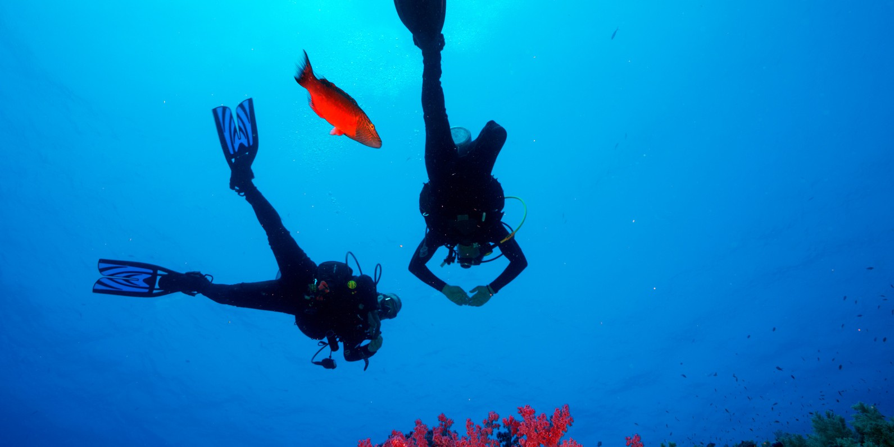

TBeauty and appearance significantly influence social dynamics, often leading to disparities based on physical attractiveness. These inequalities manifest in various aspects of life, including employment, social interactions, and mental health. This paper explores the roots, manifestations, and consequences of beauty-based social inequalities, examining cultural norms, media influence, and psychological impacts. It also discusses strategies to mitigate these inequalities, highlighting the roles of education, policy, and societal change. Social inequalities persist as a pervasive issue affecting various aspects of human life, including access to education, healthcare, economic opportunities, and justice. This paper explores the multifaceted nature of social inequalities, examining their causes, manifestations, and consequences. Through an analysis of historical, economic, and sociopolitical factors, the paper aims to provide a deeper understanding of the mechanisms driving social disparities. Additionally, it discusses strategies for mitigating these inequalities, highlighting the role of policy interventions, grassroots movements, and international cooperation. Social inequalities in beauty and appearance are pervasive and deeply embedded in cultural norms and media representations. These inequalities affect individuals' self perception, opportunities, and social interactions, often leading to discrimination and bias based on physical appearance. This paper explores the origins, manifestations, and impacts of these inequalities, examining how societal standards of beauty are constructed and perpetuated through various channels, including media, culture, and historical contexts. It also analyzes the consequences of these standards on different social groups, particularly focusing on gender, race, and socioeconomic status. Furthermore, the paper discusses potential strategies to challenge and dismantle these beauty biases, promoting a more inclusive and equitable understanding of beauty and appearance. By highlighting the complex interplay between appearance based biases and broader social inequalities, this analysis aims to contribute to ongoing discussions and efforts to achieve social justice and equality.

[http://dx.doi.org/10.2139/ssrn.4559285](https://dx.doi.org/10.2139/ssrn.4999242)

**Future Newsletter Highlights**

**1. Global Social Impact: A Month of Action and Awareness

 November marks a pivotal moment in our efforts to drive global social change. This month, we’re spotlighting the initiatives making a lasting impact in communities worldwide. From climate justice to human rights advocacy, discover how GLOBAL CENTER FOR SOCIAL DYNAMIC RESEARCH ’s partners are leading the charge for positive transformation.

**2. Social Justice in Action: Key Initiatives and Collaborations

 GLOBAL CENTER FOR SOCIAL DYNAMIC RESEARCH continues to collaborate with grassroots organizations to address urgent social issues. Learn about new partnerships and joint ventures aimed at combating inequality, promoting inclusive education, and fostering economic empowerment in underserved regions.

**3. Highlighting Youth Leadership: Empowering the Next Generation

 The future of social change is in the hands of young leaders. In this edition, we celebrate the remarkable achievements of youth activists who are making waves across the globe. Read inspiring stories from our Youth Leadership Program and how they are paving the way for sustainable social justice.

**4. Exclusive Report: The State of Global Inequality in 2024

 Our in-depth analysis on global inequality provides a sobering look at the current state of economic and social disparities. We discuss the most pressing issues and outline actionable steps that can be taken by governments, organizations, and individuals to address the root causes of inequality.

**5. GLOBAL CENTER FOR SOCIAL DYNAMIC RESEARCH ’s New Campaign: #VoicesForChange

 This month, we’re launching our new advocacy campaign, #VoicesForChange, amplifying the voices of marginalized communities. Join us in raising awareness and advocating for policies that support equity, justice, and human dignity across all borders.

**6. Partnerships for Progress: Corporate Social Responsibility in Action

 Learn how GLOBAL CENTER FOR SOCIAL DYNAMIC RESEARCH Fis partnering with corporations to foster meaningful corporate social responsibility (CSR) initiatives. These collaborations are designed to leverage business resources to support social enterprises, education, healthcare, and environmental sustainability.

**7. Upcoming Event: Global Summit on Social Dynamics

 Mark your calendars! Our Global Summit on Social Dynamics is just around the corner. This high-profile event will bring together thought leaders, policymakers, and social innovators from around the world to discuss cutting-edge solutions to global social challenges. Early registrations will be open soon.

d collaborations. As always, thank you for your ongoing support and engagement with GLOBAL CENTER FOR SOCIAL DYNAMIC RESEARCH . We look forward to seeing you at our December conference and continuing our journey of shared knowledge and discovery. Stay inspired, stay informed, and keep advancing the conversation on social dynamics with us!

HIGHLIGHTS

We hope you enjoy this issue and that it sparks new ideas an

Warm regards,

The GLOBAL CENTER FOR SOCIAL DYNAMIC RESEARCH Team

[www.globalcsdr.com](http://www.globalcsdr.com/) [www.globaljssr.com](http://www.globaljssr.com/)

Thank you for reading!

GLOBAL CENTER FOR SOCIAL DYNAMIC RESEARCH

28 A, BA BLOCK, ASHOK VIHAR PH-I, DELHI-110052 SAMIR C MINZ

DIRECTOR

(Policy, Administration and Operation) 9811385045

9711186810

9307070785

E-Journal: GLOBAL E-JOURNAL OF SOCIAL SCIENTIFIC RESEARCH

Website: [www.globalcsdr.com](http://www.globalcsdr.com/)

[www.globaljssr.com](http://www.globaljssr.com/)